Press Release

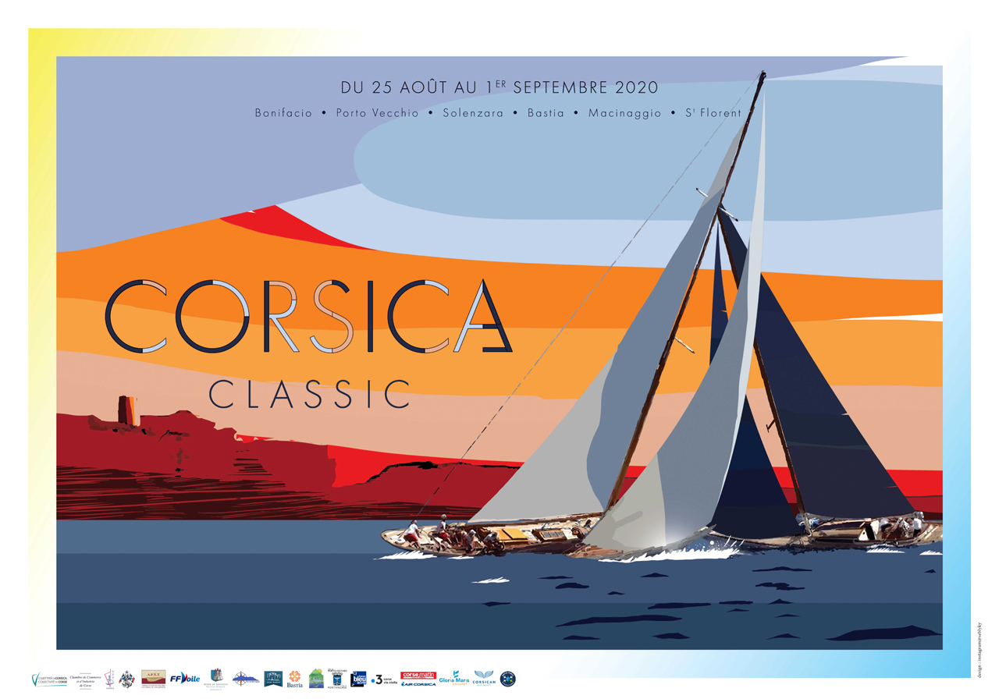
Corsica Classic
10th Anniversary
August 25th-September 1st 2020

A regatta around the Isle of Beauty, combining the spirit of competition and sportsmanship, elegance and adventure, under the patronage of the prestigious Yacht Club of France
The Corsica Classic is a highly exclusive sport and lifestyle event, part of a renowned tradition of stunning Mediterranean regattas for classic yachts.
With the Napoleon Regatta, launched this year by the Corsica Classic Yachting Organisation, Corsica Classic Regatta is an unmissable event in the Mediterranean Sea positioned as the first classic race on the Isle of Beauty. In the official 2020 Yachting Calendar, the Corsica Classic is with the Napoleon Regatta - which took place from July 20 to 25 in Ajaccio -, the first regatta of the year in the Mediterranean Sea. In fact, due to COVID-19, all events were canceled or postponed to fall.

Open to all traditional CIM Yachts and "Spirits of tradition" gauged IRC 2020, this race is part of the official tour organised by the Mediterranean International Committee and the French Organisation of Traditional Yachts (AFYT).

HISTORY, ARCHITECTURE AND HERITAGE

YACHT CLUB DE FRANCE // The regatta is under the patronage of the Yacht Club of France since 2014, a mark of great prestige. Created in 1867 by Napoleon III, the highest sailing institution in France has had very prestigious members, such as the polar explorer Charcot, Jules Verne or Eric Tabarly. Every year, the Yacht Club de France offers its prestigious "Tape de Bouche", in bronze and wood, to the sailboat with the most "Yachting" spirit”. A prestigious label for the greatest classic sailing gathering in Corsica...
www.ycf-club.fr // Instagram : @yacht_club_de_france
FLOATING PIECES OF ART // The past 10 years, a hundred classic yachts - among the most beautiful in the world - have participated in the Corsica Classic. These pieces of art are always ready to play on the water, even at more than 80 years… This year, the cast will be historic with nearly 30 exceptional sailboats participating: The faithful participants, such as SY Skylark, property of Tara Getty, will also be accompanied by his classic 1938 motoryacht, Bluebird. SY Vistona, owned by Duke Gian Battista Borea d´Olmo, big Italian favorite in his class, which has 9 Corsica Classic to his credit, SY Saint-Christopher, winner of Les Voiles de Saint-Tropez 2018 in the Classic class, SY Eileen, overall winner of the Corsica Classic 2019 - Epoque Marconi- class, alongside SY Hygie and SY Olympian, triple overall winner of the Corsica Classic. Class Esprit de Tradition (recently built sailboats with a vintage look) announces a beautiful nautical battle between seasoned SY Mr Fips and SY Scherzo. For the first time, SY Hild 1899, freshly renovated, marks here its come back to regatta tour...

DORADE TROPHY // In 2014, Corsica Classic was won by an American pavilion yacht: SY Dorade, a Marconi designed by the famous architect Olin Stephens in 1929, winner of a Fastnet and a Transatlantic Newport-Plymouth in 1931. Proud of this trophy, the Californian owners of SY Dorade have created in 2015 a “Dorade Trophy” especially for the Corsica Classic: each year, this trophy, a Bronze’s winch of 20 kg, a historical and original piece of the yacht, is awarded to the winner of the Epoque Marconi class. SY Eileen has been its proud owner for a year. Every year, it is putting back into the game in the manner of the American Cup.
www.dorade.org // @ doradesailing1929

HISTORICAL MONUMENT // On Wednesday August 26th, Corsica Classic crews will have privileged access to the historic enclosure of the fortifications of Bonifacio: the Bastion de l'Etendard, the Stronghold of the Standard, considered the highest in France, is a historical and strategic place for the defense of the city. Its terraces offer exceptional views of the port, the cliffs and Sardinia. Siege of King Aragon in 1420 and Franco-Turkish in 1553, it contains vestiges of Pisan and Genoese periods from the 12th and 13th century. It is in this place, dominating the sea ​​and the port that all participants will gather for cocktail and opening dinner, respecting sanitary measures.
www.bonifacio.fr // @bonifaciotourisme

LIFESTYLE, GASTRONOMY & LOCAL PRODUCTS

PRIVATE DINERS // Bonifacio:
It is in the citadel of Bonifacio, in the heart of the Stronghold of the Standard, classified historic monument and privatised for the occasion, on Wednesday August 26th, that will be host the Corsica Classic opening dinner. At the helm, André Zuria, Chef of Terrasses d´Aragon in Bonifacio will prepare a four-handed, farm to table dinner with the Chef Joëlle Boccheciampe, Aubergines à la Bonifacienne, and Label Rouge grilled fish from Corsican farms of Gloria Maris, accompanied by wine from Domaine Zuria and followed by Brie de Meaux farmhouse AOP Edmond de Rothschild Heritage.

Saint-Florent:
The closing dinner will be held on Tuesday, September 1st at the citadel of Saint-Florent and will highlight the island's exceptional products: fishes made in Corsica Gloria Maris, Corsica olive oil from Château NasicA, accompanied by Clos Signadore Patrimonio wines. As a starter, a Label Rouge Gloria Maris ceviche and vegetables signed by Yann Le Scavarec, Chef & owner of the restaurant La Gaffe on the port of Saint-Florent, a signature main dish signed by four hands with Chef of the Corsica Classic Joëlle Boccheciampe and Damien Muller, owner of the Auberge du Pêcheur in Saint-Florent, while the dessert, the Hazelnut chocolate, will be signed by La Roya’s chef, Aurélie Moreschi.
www.aubergedupecheur.net // Instagram @laubergedupecheur
www.gloriamarisgroupe.com // Instagram @gloriamarisgroupe
www.restaurant-saint-florent.com
www.hoteldelaroya.com // Instagram @latabledelaroya
Instagram @joe_b4you

EDMOND DE ROTHSCHILD HERITAGE // The latest Brie de Meaux AOP with a farmer label, signed by Edmond de Rothschild Heritage, will be on the menu for the Corsica Classic opening dinner on August 26th at Bastion de l’Etendard. Nicknamed the “King of desserts, the Dessert of kings”, this French tradition from le Pays de Brie requires 25 liters of milk per wheel (3.6 kg) and 4 weeks of ripening to give birth to its aromas of pasture and hazelnut, to its slightly creamy heart and to its white rind. At the Edmond de Rothschild Heritage farm, Baroness and Baron Ariane and Benjamin de Rothschild, on the family land from Favières (77), perpetuate this artisanal tradition while respecting the rhythm of nature. Here the cows are fed with grass from the farm, milked on site and the milk immediately processed by hand, following the charter of farmer label products, in the purest respect for the traditions of this exceptional product.
https://epicerie.edmondderothschildheritage.com/en // Instagram @edmondderothschildheritage

EXCEPTIONAL OIL // CHATEAU NasicA olive oil is one of the oldest olive groves of Corsica. In 786, Amondo Nasica Amondaschi was one of the 5 Lords to accompany Charlemagne to Corsica on the orders of Pope Clément. Its trees are now sometimes thousands of years old, from an almost forgotten endemic variety, the Smadja Niellaghia, with an exceptional taste and a polyphenol level greater than 600mg / L, like the best oils in world. Today, Marie-Ange Mattei, heiress of the NasicA dynasty, gives life back at this estate located in Prato de Giovellina, near Bastia and the Natural Park Regional of Corsica with a first oil from 2017. On the tables of Corsican Michelin-starred Chefs, as well as at Jean-George Vongerichten in New York, Aspen and Shangai, the Chefs of the Corsica Classic will prepare their dishes with this exceptional island material and the participants in the regatta will be offered baskets filled with Corsican sweets, macaroons and other surprises signed CAFFE DE FLORE 1755, owned by the same family.
Instagram @chateau_nasica
www.caffedeflore.com // Instagram @ caffedeflore1755

GLORIA MARIS GROUPE, main player in aquaculture excellence in France, will be the official supplier through its historical production site in Corsica, Acquadea, a European reference in sustainable and responsible aquaculture, during the opening and closing dinners of the Corsica Classic. The most beautiful Mediterranean products will be tasted during this gastronomic journey...
www.gloriamarisgroupe.com // Instagram @gloriamarisgroupe

The sailors will be able to refresh themselves during well-deserved breaks offered by the PIETRA BRASSERIE. Blonde, organic, white, gluten-free, with chestnuts… Corsican beers will be in the spotlight, and in particular the blonde Ale and the Session IPA baptized Napoléon and Joséphine, served from the Pietra Brasserie emblematic food truck that will stop in different harbours during the regatta.
www.brasseriepietra.corsica // Instagram @brasseriepietra

L.N. MATTEI, creator of the Capo Spritz - red or white - the signature cocktail made in Corsica, will be present during the various stages of the regatta. The Mattei house, founded in 1872 by Louis Napoléon Mattei is also the signature of the flagship aperitif
of the isle of beauty. The recipe of Cap Corse Mattei is still one of the best secrets kept in Corsica...
www.capcorsemattei.com // Instagram @capmattei

OLD PULTENEY
This Scottish whiskey places its anchor in Corsica during the Corsica Classic: Called the "Maritime Malt", this exceptional Scotch made in the port of Wick, in the North of Scotland is distributed in France by La Maison du Whisky. In the 19th century, the port of Wick is one of the most active in Europe. Accessible only by sea, the town was recognized for the export of its casks of silver (herring) and gold (whiskey). Since 1826, the malt of whiskey Old Pulteney is grown by the sea, giving it rich notes and a saline, iodized character that works in perfect harmony with the seafood for a balanced and original food-pairing.
www.oldpulteney.com // Instagram @oldpulteneymalt
www.lmdw.com // Instagram @maisonduwhisky

MAISON DE LA BOTTARGA
In Bastia, Bottarga is also called caviar… Made with mullet eggs, dried and salted, the Bottarga is made on site, by Marinella, José Blardi’'s sardinian wife. Formerly, quai des martyrs, salted Bottargas dried in the sun, directly in the street. That’s where, today, La Maison de la Bottarga has just set up its own restaurant & grocery store, nearby the old port in order to perpetuate the local tradition...
www.maisondelabottarga.fr // Instagram @maisondelabottarga

LES TERRASSES D’ARAGON // This Bonifacian cutlery manufactures handcrafted Corsican knives for 35 years. The Zuria family, with the help of the Meilleur Ouvrier de France Robert Beillonnet produces collections of exceptional knives in the precious woods of the isle of beauty, and in particular original sailor's knives, traditional sculpted pieces of art. The winners of the Corsica Classic will win an exceptional knife at the awards ceremony in Bonifacio and Saint-Florent.
www.lesterrassesdaragon.com // Instagram @lesterrassesdaragon

DOMAINE ZURIA, BONIFACIO
Domaine Zuria was created in 2010 by Christian and Nadine Zuria, in order to revive the Bonifacio wine soil, which had completely disappeared over the years. Wine in Bonifacio? Yes Sir ! In 1850, there were 450 hectares of vineyards in Bonifacio, in the extreme south of the island. The adventure has started on the family land. Today, Domaine Zuria has 13 hectares, entirely planted with endemic Corsican grape varieties, above from the Gulf of Sant ’Amanza, where the Corsica Classic will start. The house produces red wine (100% Sciacarellu grape), rosé and white (a blend of Vermentino, Bianco Gentil and Genovese). The wines of Domaine Zuria are nothing like any other Corsican wine. They owe their sophistication, delicacy and character to the large limestone plateau which saw them born and with a touch of femininity signed by Aurélie Patacchini, consultant winemaker. With three ranges: Aria, cultivated on granite soils, DZ, available in 3 colors and the plot wine batchs vinified in wooden barrels: Stintinu (red) and Crocci (white). To keep all its flavors, the precious nectar of Stintinu, once bottled, is kept 5 months in a Bonifacian cave to be aged in optimal conditions...
www.domainezuria.com // Instagram @domainezuria

DOMAINE GRANAJOLO, PORTO-VECCHIO
Planted in 1974 by Monika and André Boucher, the 20 hectares of the family vines have always been driven in organic farming. Today their daughter Gwenaële took the winery over… On the granite hillsides, in Sainte-Lucie de Porto-Vecchio, its Corsican grape varieties grow in the sun 3 km from the sea: Niellucciu, Sciaccarellu and Vermentinu make up the red, rosé and white wines. The wines of Domaine Granajolo will be tasted during the Porto-Vecchio’s stopover.
www.granajolo.fr

DOMAINE CLOS SIGNADORE, PATRIMONIO
In 2001, at 25 years old, Christophe Ferrandis acquired 4 hectares of Niellucciu on the Patrimonio lands. He quickly switched to a sustainable process then to organic in 2010. Vinified in an ancient sheepfold in Morto Piana, harvested by hand, its Clos Signadore is a concentrated wine, in white, rosé and red. Sweet,
spicy, ripe, complex and deep, it is made up of Corsican grape varieties -
Niellucciu and Vermentinu - on 4 plots labeled AOP Patrimonio and Bio Ecocert- organic. Clos Signadore wines will be tasted during the closing dinner in Saint-Florent and magnums will be offered to the winners of the race.
www.signadore.com // Instagram @clos_signadore

CALLYSTHE // The first brand of premium teas and infusions made in Corsica will offer its limited edition of “Un été en Corse” tea to each of the participants, to extend their trip to the isle of beauty after the regatta... “Un été en Corse” is the perfect alliance between Pai Mu Tan white tea from China and Sencha green tea from Japan married to the fresh and fruity flavors of peach, apricot, pear, orange peel and lemon, mint and hibiscus. Ideal for summer, taste this tea hot or iced! In 3 years, this young brand has become unmissable in Corsica and beyond... Each blend is made in collaboration with various tea producers and Corsican herbalists, offering unique flavors.
www.callysthe.com // Instagram @callysthe_fr

THE MOST BEAUTIFUL STOPOVERS IN CORSICA

AIR CORSICA // The island airline Air Corsica renews its privileged partnership with the Corsica Classic. With strong development at international from Brussels-Charleroi (since March 2017) and London Stansted (reopening in 2021), Porto (since April 2019), Göteborg (reopening in 2021) as well as Salzburg and Vienna (from August 2020 on), Air Corsica allows international travelers connections directly to Corsica. The first Corsican air carrier is expanding its territory to showcase the isle of beauty to the world !
www.aircorsica.com // Instagram @aircorsicaofficiel

A DREAM JOURNEY // U Capu Biancu Resort, located in the bay of Sant'Amanza, will be the starting point for the fleet for the first time this year. In front of the hotel, the sailboats will anchor on Sunday 23th August for three days. Then, they will head to Bonifacio and its Bouches, the Lavezzi islands, Les Cerbicales, the bay of Porto-Vecchio, the Aiguilles de Bavella, Sari-Solenzara, Bastia, its old port and its citadel, Macinaggio, Cap Corse, La Giraglia and finally Saint-Florent... A succession of coastal races for the day of twenty miles (from 2,30 hours to 7 hours of navigation per day) which will lead the yachts to anchorages every evening in exceptional places, with a total of 180 nautical miles traveled in 7 days. An unforgettable adventure...
www.ucapubiancu.com // Instagram @ucapubiancu
www.bonifacio.fr // @bonifaciotourisme
www.ot-portovecchio.com // @portovecchiotourisme
www.cotesdesnacres.com // @otcotedesnacres
www.bastia-tourisme.com // @otbastia
www.macinaggiorogliano-capcorse.fr // @macinaggio_rogliano_capcorse
www.mairiedesaintflorent.fr // @port_saint_florent
www.visit-corsica.com // @visitcorsica

U CAPU BIANCU 4 * HOTEL // This elegant residence was conceived and designed by
its owners like a resort inspired from an exotic place on the other side of the world. Warm and welcoming, exceptional but without artifice, everything is true in this discreet address which melts into the maquis on the heights of the Gulf of Sant'Amanza. It is in front of this magical place that the Corsica Classic will take off on Wednesday August 26, after a private cocktail on the beach, on August 25th. Everything at Capu Biancu invites you to relax: suite with private pool, spa with breathtaking view, a private beach, exotic and farm to table menu (Corsican shrimp pasta, tiramisu with Nuciola, etc.).
www.ucapubiancu.com // Instagram @ucapubiancu

FOR ESTHETS

OFFICIAL POSTER // Each year, the overall winner of the Corsica Classic is found in the spotlight on the official poster following his trophy. This year, its SY Eileen, winner overall 2019, who crosses the road of SY Quatre-Quarts, is represented on the official poster designed by the creative director and artist Sébastien Lyky, who works for the biggest luxury brands, from Cartier to Louis Vuitton, via Hermès and Celine.
Instagram @seblyky

QUAY AUSTRALIA // The Australian eyewear brand Quay Australia will dress up all the staff and participants of Corsica Classic. These trendy sunglasses who signed collaborations with Jennifer Lopez, Chrissy Teigen or Lizzo seduce countless celebrities around the world: from Sarah Jessica Parker to Kristine Cavallari or Molly Sims. In 14 years of existence, the brand has dressed up many events, festivals and personalities, creating the #quaysquad. Each participant of the regatta will proudly wear a 2020 model signed Quay Australia.
www.quayaustralia.fr // Instagram @quayaustralia

CLARINS // Clarins becomes for the first time an exceptional partner of Corsica Classic. This is the opportunity for the brand to highlight new innovative products that enrich its sun line: high protective care performance, sensory and invisible on the skin, on the other hand, after-sun products soothing. The advantage: an eco-responsible commitment with eco-friendly packs and unique formulas that respect the life of corals. Assortments of products for men, sunscream, Eau Dynamisante and make-up will be offered to the winners of the Corsica Classic during the awards ceremony on Tuesday, September 1st, in Saint-Florent.
www.clarins.com // Instagram @clarinsofficial

EAU DE CONVENT-SAN FRANCESCU // The Eau de Convent line of products has self-imposed at its creator, Candida Romero, artist at heart and painter by profession, who has unearthed and invested a unique site in Corsica: the San Francescu convent in Oletta. For 20 years she has been going there regularly and religiously to bring it back to life through art and to imagine perfume waters, body products, candles, etc. with a delicate and generous olfactory imprint. As an extension of the protection of this precious heritage, these dreamlike and 100% natural Corsican creations are inspired by this mystical convent and will be offered to the winners of the regatta, during the final prices in Saint-Florent.
www.eaudecouvent.com // Instagram @eaudecouvent
www.sanfrancescu.com // Instagram @sanfrancescu

CORSE PRESTIGE IMMOBILIER - CHRISTIE’S // The Real Estate Agency becomes partner of the Corsica Classic for the first time. Emmanuel Castellani and his team have built up a loyal clientele throughout the island from the extreme south of Corsica, to the Gulf of Ajaccio, via Balagne or the Cap Corse. The discretion and integrity of the teams make them an essential actor for the luxury real estate market on the island, for more than 20 years. At the quayside, the Corsica Classic fleet will proudly wear the flags of this prestigious brand with an international reputation.
www.corseprestige.com // Instagram @corseprestige

ENVIRONMENT

CLEAN SEA OPERATION // At the initiative of Saint Florent’s Port, Corsica Classic, the Corsican Blue Project and Water Family Organisations, a new collect action will take place during the last three days of the Corsica Classic, from Bastia to Saint Florent. In the area of ​​the Marine Park of Cap Corse and of Agriates, the new Manta trawl designed by the Corsican Blue Project Organisation will set sail for a collect of macro and micro-plastics on August 30th, 31st and September 1st. Actions are also planned on land with awareness stands at the arrival of the Corsica Classic, in the St Florent port where sorting, counting and weighing of collected wastes will be carried out. In close collaboration with the Marine Park and the Stareso Station, this operation will be monitored scientifically. The associations have also worked on a environment chart which will be given to all sailors at the beginning of the regatta and followed throughout, with an environmental Award given on arrival. In the old port in Bastia on the evening of August 29th and on august 30th in the morning; in Saint-Florent on August 31st and September 1st.
www.corsicanblueproject.com // Instragram @corsicanblueproject

VIP GUESTS

TANIA YOUNG // For the seventh consecutive year, Tania Young the TV French television's Darling, is the official Godmother of the race : After anchoring the weather forecast and the travel show in prime-time, Faut Pas Rêver, Tania Young now presents her chronicle of unusual trips for France 2’s flagship program, Télé Matin.
Instagram @taniayoungofficiel

SOS CANCER DU SEIN // Corsica Classic will once again host, as for the past 6 years, the SOS Breast Cancer Organisation and its "Pink" Regattas. At this occasion, women with breast cancer or in remission will participate in the Corsica Classic aboard the yachts during the regatta in Saint-Florent, Tuesday September 1st. These steps will allow these women to experience a moment of exception and share with the crews who will help them to take and find their place on board.
www.soscancerdusein.org

Program 2020
Monday 24/08: Registration & Welcome day, hotel U Capu Biancu, Bonifacio

Welcoming of the fleet, anchorage opposite of the hotel in the Gulf of Sant'Amanza
10 AM – 5 AM: Registration at the hotel's outdoor "Wind Shelter" terrace

Tuesday 25/08: Registration & Welcome Day at the Hotel U Capu Biancu, Bonifacio

Welcoming of the fleet, anchorage opposite of the hotel in the Gulf of Sant'Amanza
9 AM - 5 PM: Registration at the hotel's outdoor "Wind Shelter" terrace
7 PM – 9 PM: Welcome Cocktail on the beach, hôtel U Capu Biancu x CCY
Wednesday 26/08: Regatta I Gulf of Sant’Amanza-Bonifacio

10 AM: VHF briefing - channel 72
11AM: Departure of the fleet, anchorage of Sant'Amanza
12 PM: Departure from port, Trophy Bonifacio City
7 PM: Cocktail party & awards ceremony for the Trophée de la Ville-Antoine Zuria, Stronghold of the Standard, Bonifacio
8 PM - 11 PM: Dinner of Bonifacio City Trophy - Antoine Zuria, prepared by the Terrasses of Aragon, in partnership with Edmond de Rothschild Heritage, Château Nasica olive oil, Caffe de Flore, Gloria Label Rouge fish Maris Groupe and the wines of Domaine Zuria.

Thursay 27/08: Regatta II Bonifacio-Porto-Vecchio

10 AM: Briefing
11 AM: Departure from the Harbor
12 PM: Departure from Bonifacio-Porto-Vecchio
8 PM: Welcome Cocktail, Porto-Vecchio port

Friday 28/08: Regatta III Porto-Vecchio-Sari-Solenzara
10 AM: Briefing
11 AM: Departure from the Harbor
12 PM: Departure from Porto-Vecchio
7 PM: Welcome Cocktail at Sari-Solenzara

Saturday 29/08: Regatta IV Sari-Solenzara-Bastia hold Harbor

10 AM: Briefing on the harbor quay

11 AM: Departure from the harbor
12 PM: Departure from Sari-Solenzara-Bastia hold Harbor
8 PM – 2 AM : Arrival of participants in Bastia Vieux-Port, Welcome Drink at Brasserie Pietra Beer Truck

Sunday 30/08 : Régate V Bastia-Macinaggio

10 AM: Briefing on the harbor quay, Bastia vieux-port
11 AM: Departure from Bastia harbor
12 PM: Departure from Basstia - Macinaggio
7 PM – 8 PM: CCY Welcome cocktail, Le Vinci Bar

Monday 31/08: Régate VI Macinaggio-Saint-Florent

10 AM: Briefing on the harbor quay, Macinaggio
11 AM: Departure from the harbor
12 PM: Departure from Macinaggio – Saint-Florent
7 PM: Welcome cocktail at Saint-Florent, served on board

Tuesday 01/09 : Régate VII, Saint-Florent Bay

10AM: Briefing on the quay, Saint-Florent
11AM: Departure from the harbour
12 PM: Departure of Saint-Florent-Saint-Florent regatta
7 PM – 8 PM: Corsica Classic awards ceremony, Citadelle de Saint-Florent
8 PM – 11 PM: Dinner, Saint-Florent Citadel. Starter signed by Yann Le
Scavarec, La Gaffe, Saint-Florent. Main course signed by Damien Muller, master -
fisherman, L'Auberge du Pêcheur Saint-Florent in collaboration with the Chef
of the Corsica Classic, Joëlle Boccheciampe. Dessert signed by Aurélie Moreschi from La Table de la Roya, Saint-Florent. In partnership with Gloria Maris
Group, NasicA castle, Caffe de Flore and Clos Signadore wine.

Twitter : @CorsicaClassic
Instagram : @corsicaclassic
Facebook : Corsica Classic
#corsicaclassic
site officiel : www.corsica-classic.com
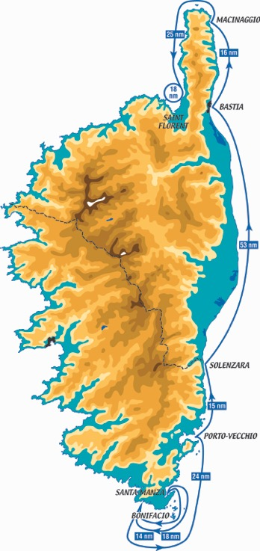

Press Contacts :
Laura Tudal, Press Relations Manager
+33 6 98 75 18 43
laura.tudal@live.fr

Katia Kulawick-Assante, Co-organizer and Communications Director :
+33 6 25 89 39 22
katiakulawickassante@gmail.com

Thibaud Assante, Founder
+33 6 84 95 57 84
presse@corsica-classic.com

